**Cloud Computing: UE20CS352**

**Assignment 5: AWS KMS**

**-Adithya M, Section K**

**-PES1UG20CS621**

**1a.png: Showing KMS key created.**

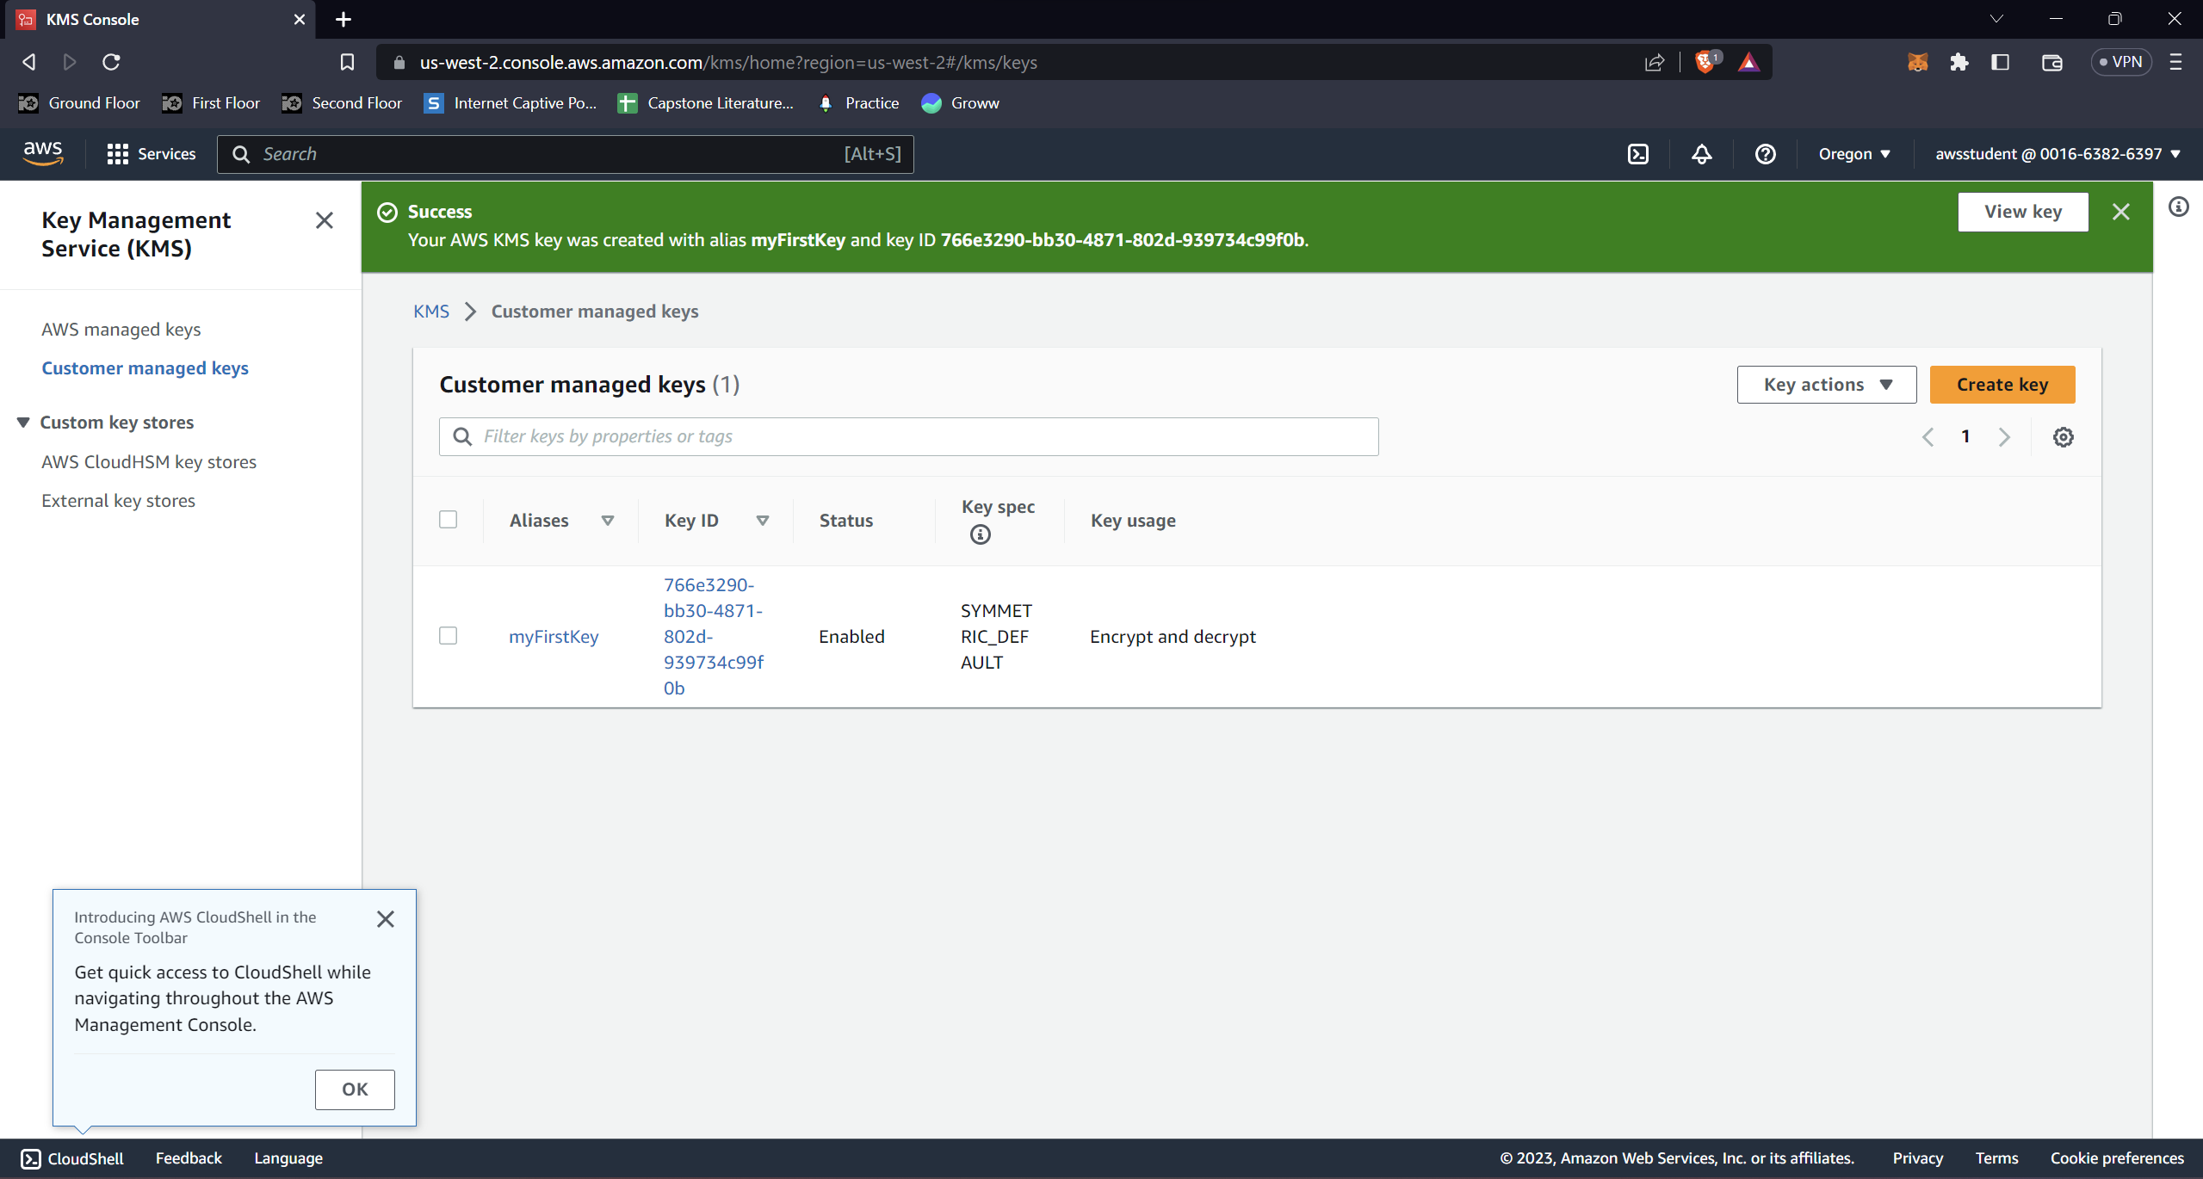

**2a.png: Showing the configured CloudTrail.**

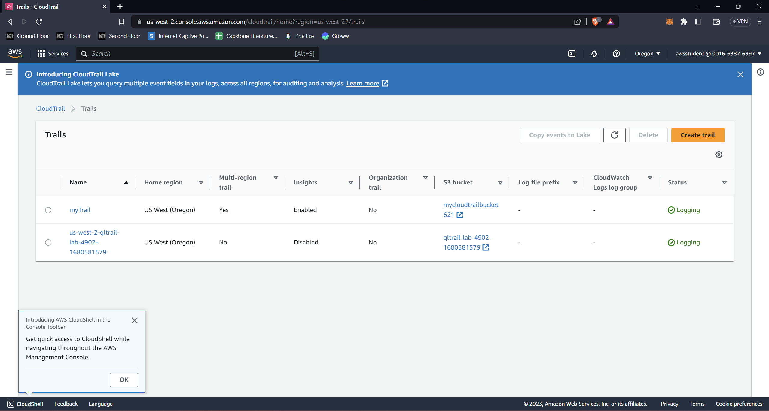

**3a.png: Showing the configured bucket**

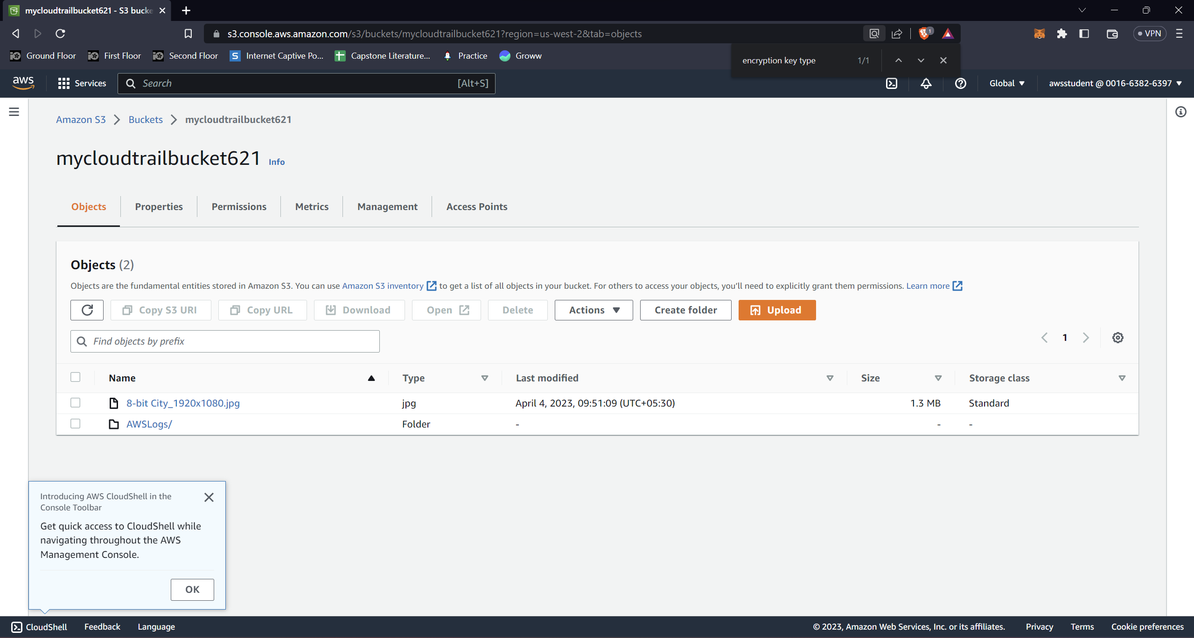

**4a.png: Showing the “Access Denied” page when you open the link to the image stored in the bucket.**

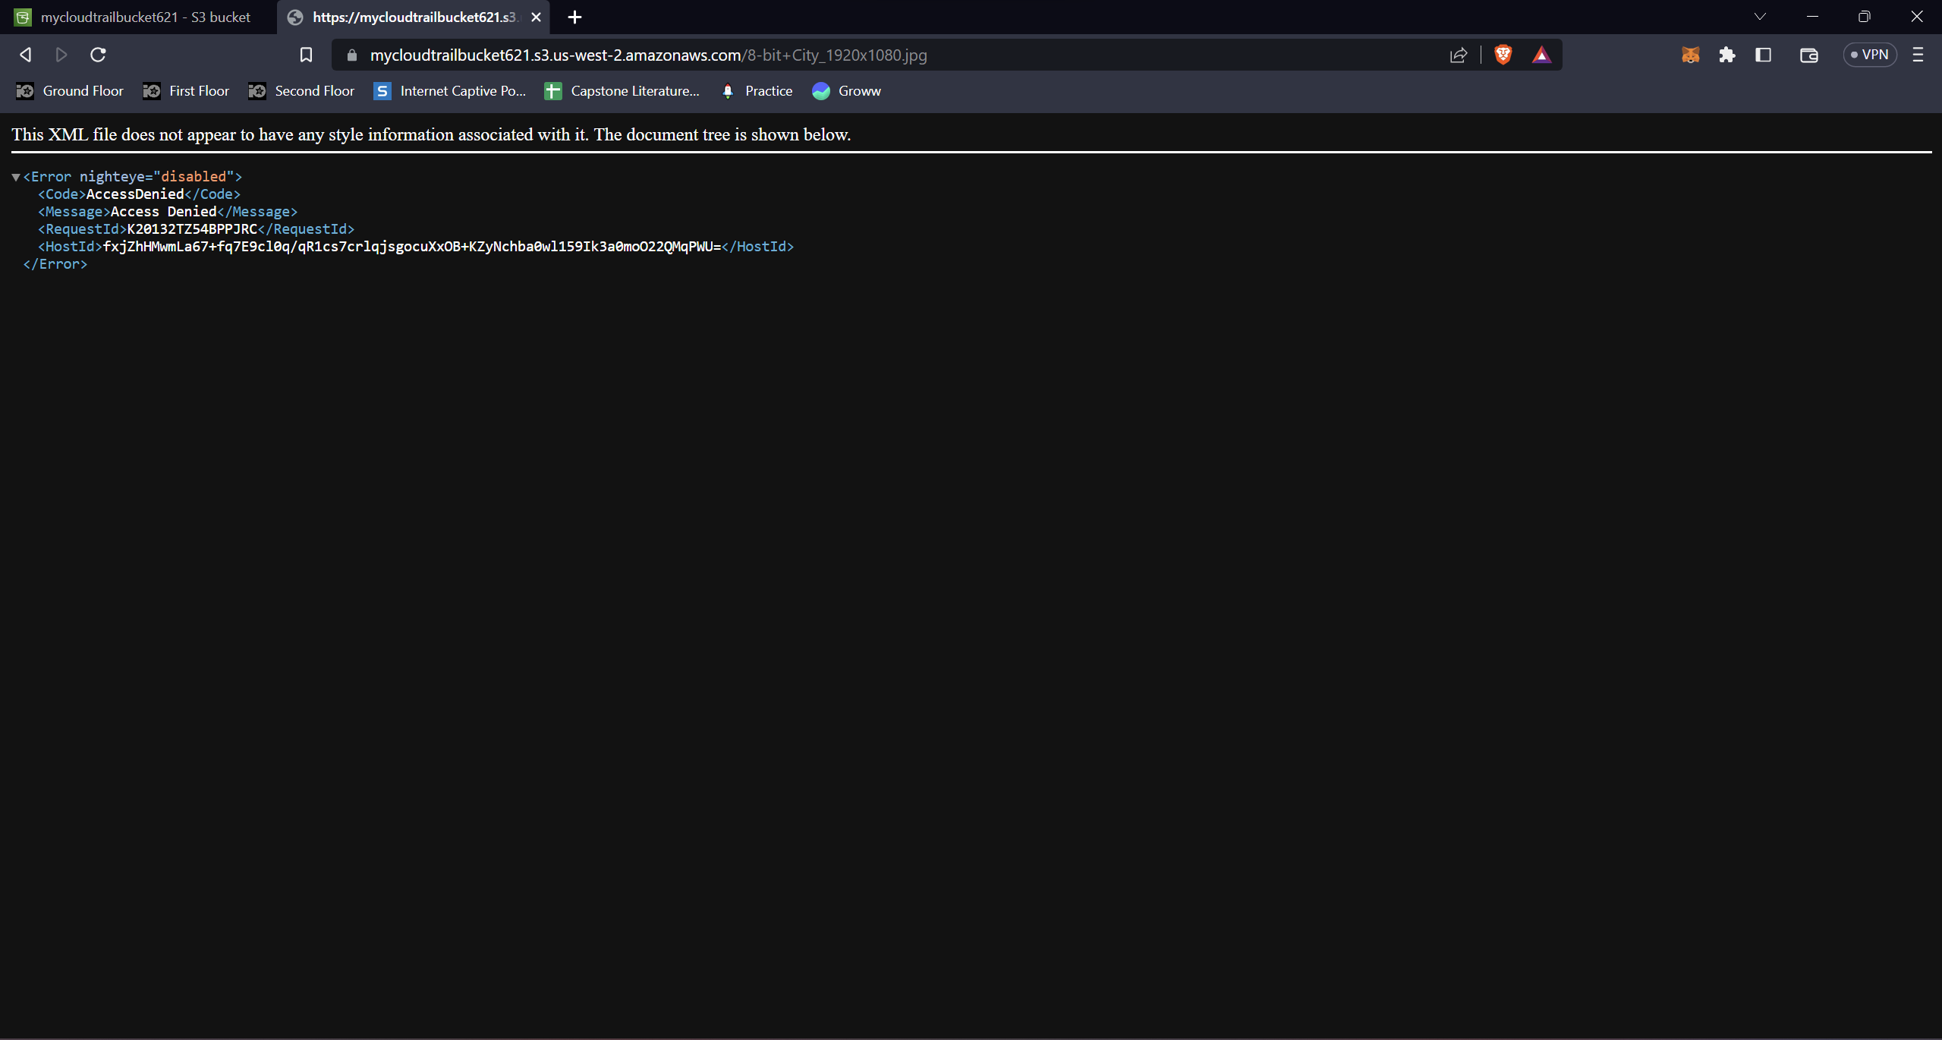

**4b.png: Showing the “Requests specifying Server Side Encryption with AWS KMS managed keys require AWS Signature Version 4” page when you open the link to the image stored in the bucket.**

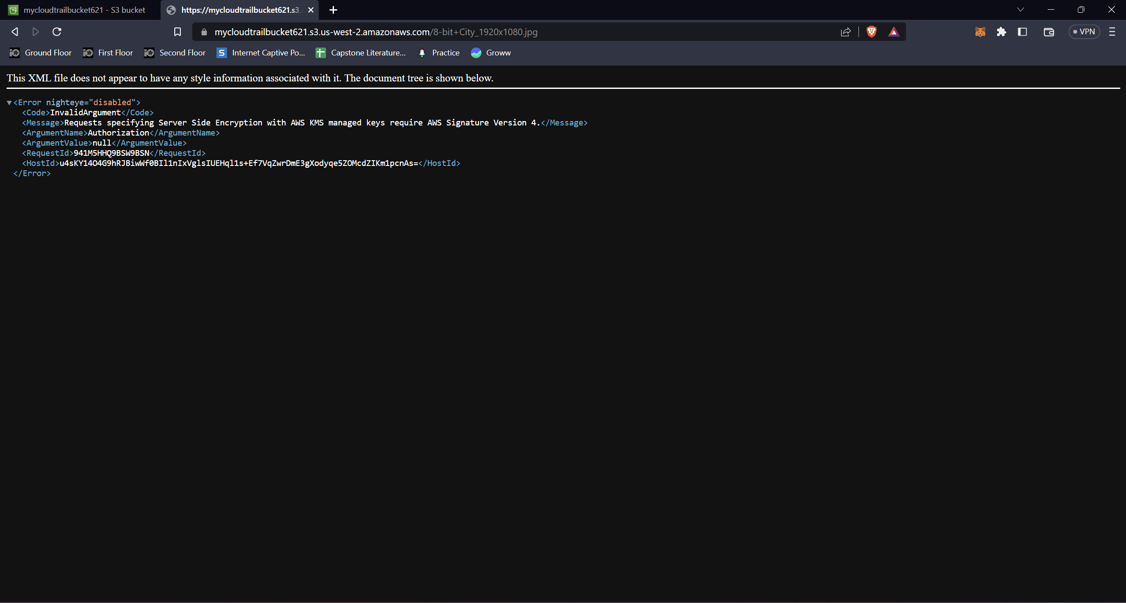

**5a.png: Showing the key-id being present in the json we get from .gzip’ed cloud trail logs.**

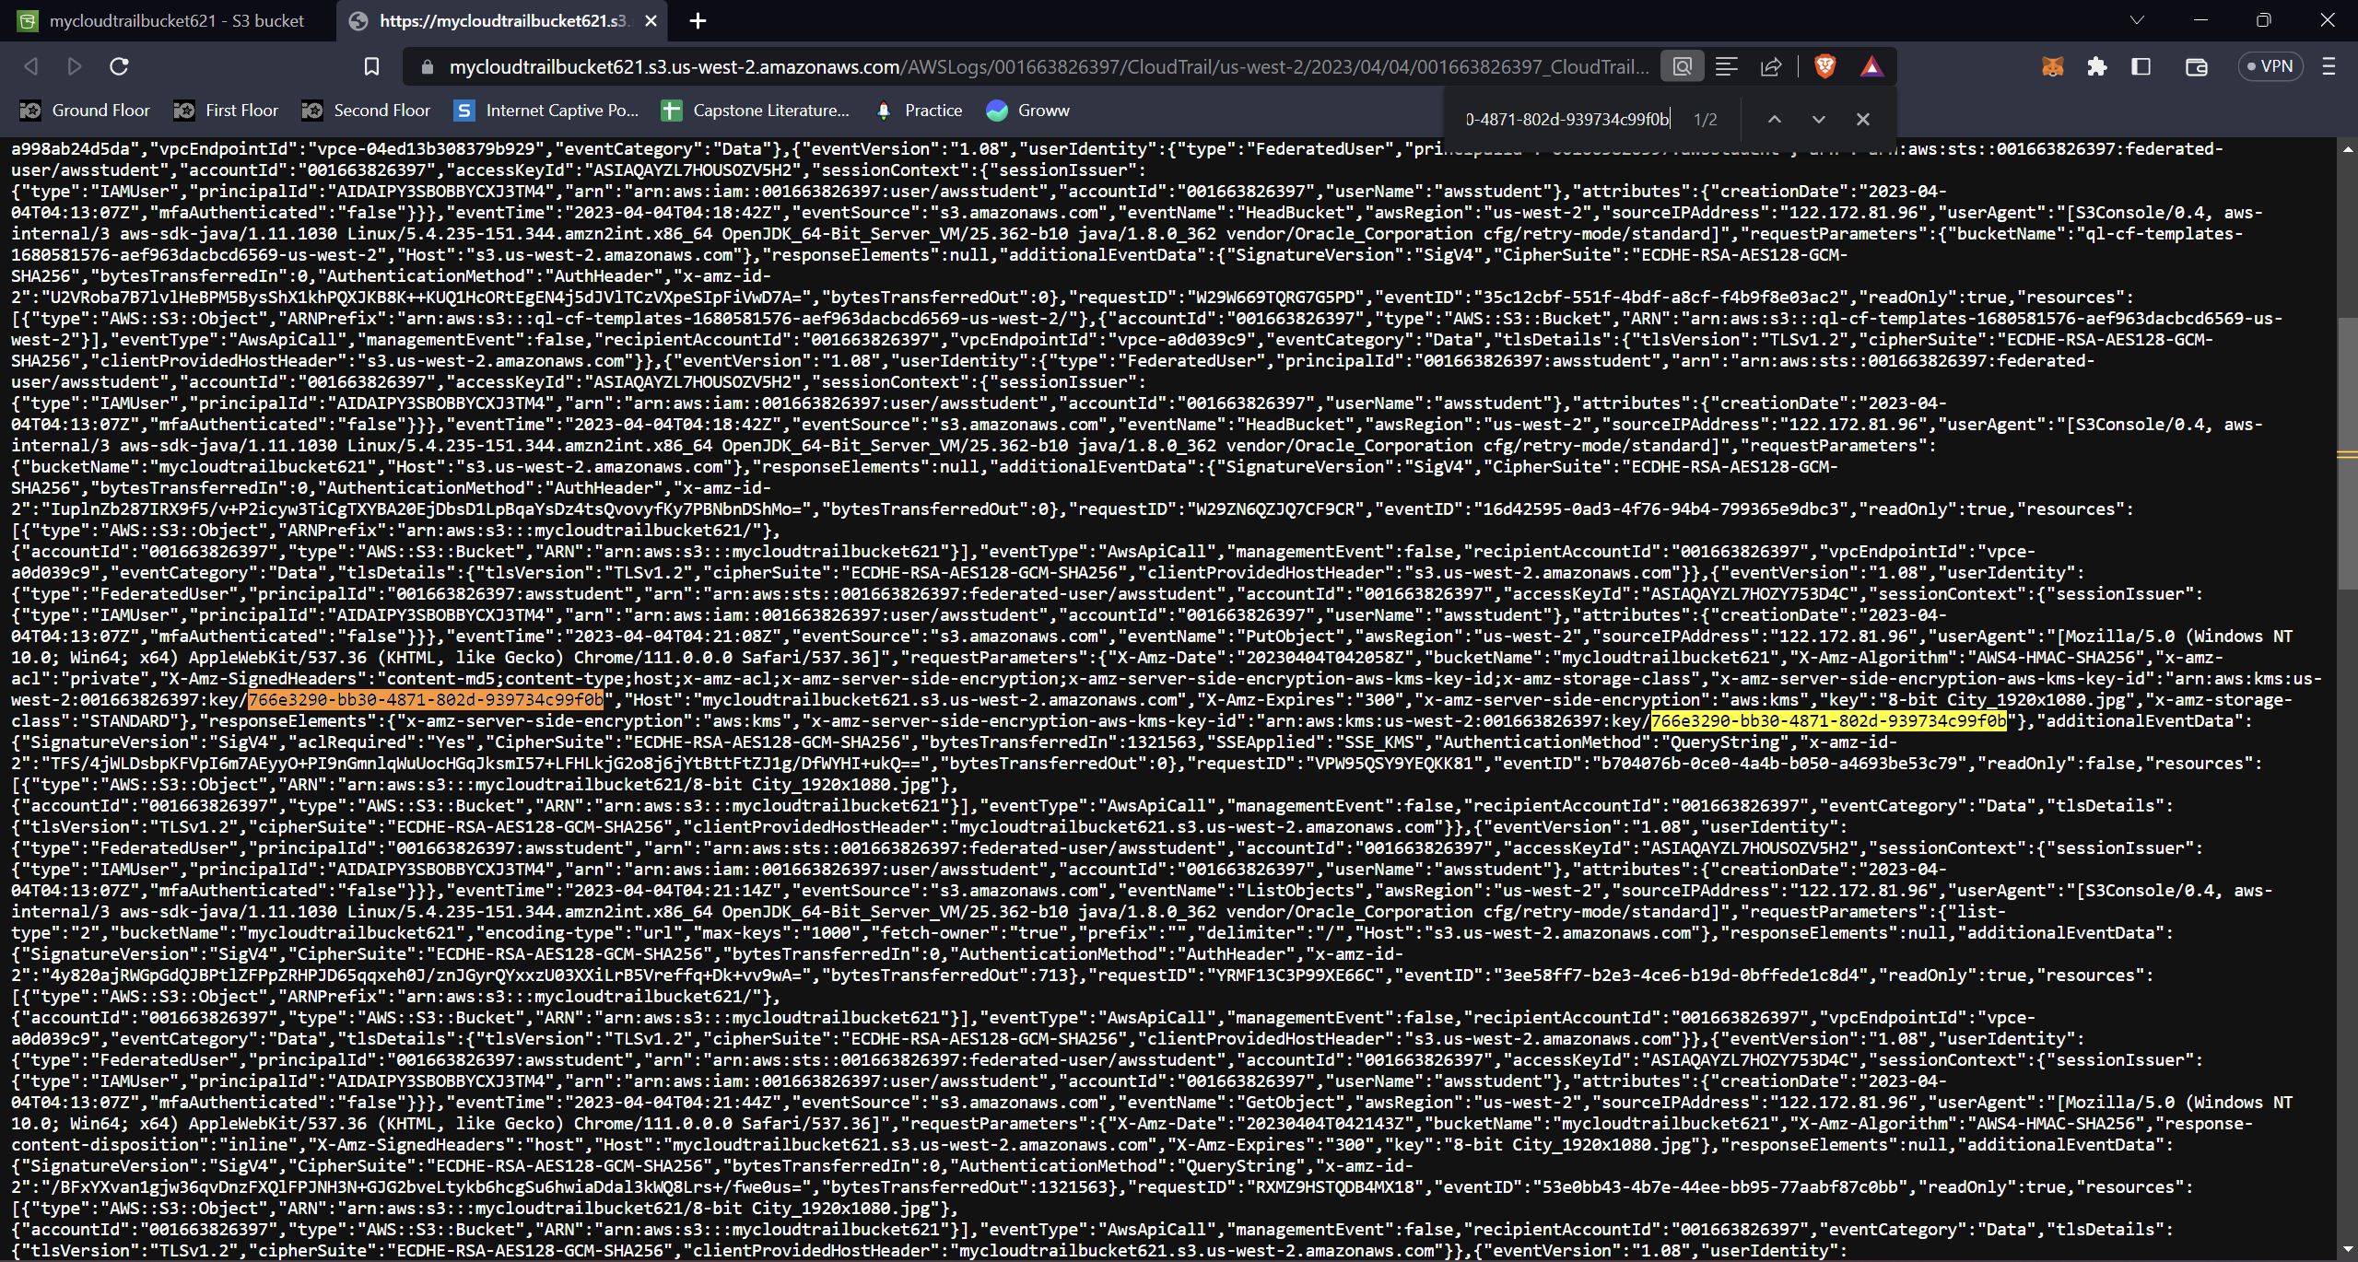

**6a.png: Showing the state of key users after the user has been removed.**

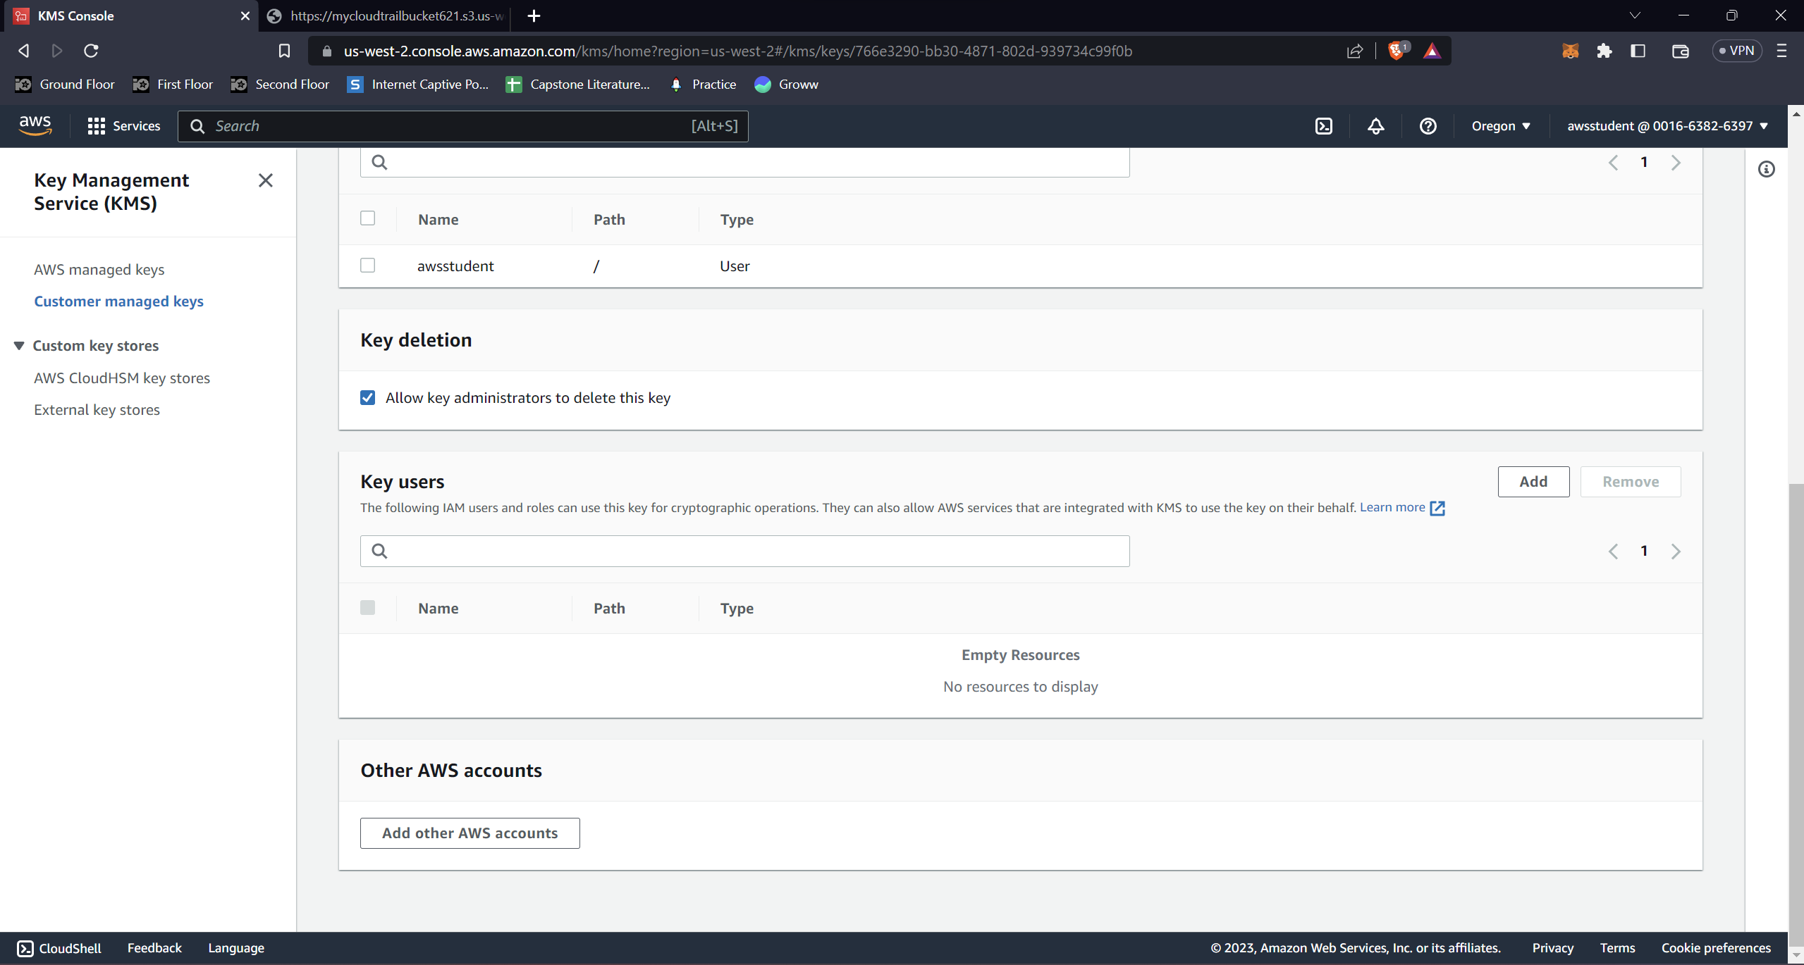

**6b.png: Showing the state of key users after the user has been added.**

